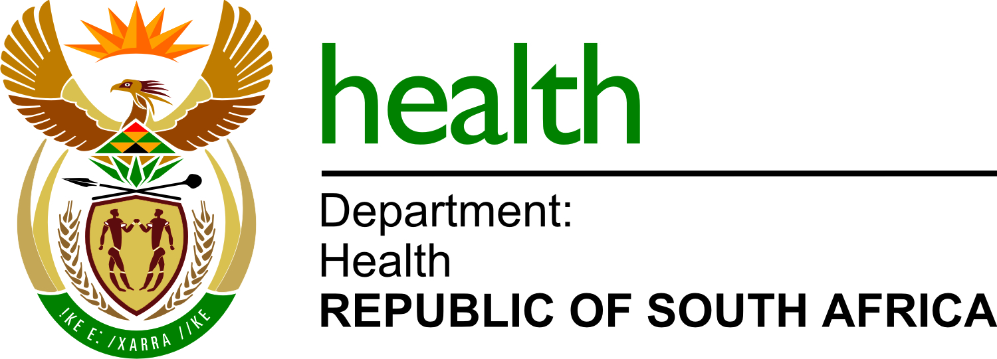

NDOH 12/2021-2022
Provision of cleaning and hygiene services at the National Department of Health ; Dr AB Xuma building for a period of 3 years.

List of bidders
1. | Yamkelanathi Holdings (Pty) Ltd
2. | Medilac Group (Pty) Ltd
3. | Siyandoba General Enterprises
4. | Sediba SA Pula trading enterprise (Pty) Ltd
5. | Mmelta Group cc
6. | Pelane A Mokatla (Pty) Ltd
7. | Superbuys Group (Pty) Ltd
8. | Olethu Security Guard and Construction Services
9. | Zuri Global
10. | Khumbo Security and Cleaning (Pty) Ltd
11. | Ndalo Intergrated Facilities Management Services (Pty) Ltd
12. | Seroko76 (Pty) Ltd
13. | Mpho To Maeong (Pty) Ltd
14. | CSK Cleaning Services (Pty) Ltd
15. | Delta facilities Management (Pty) Ltd
16. | Kgatisi Trading (Pty) Ltd
17. | Khera Cleaning and Services (Pty) Ltd
18. | Katekathi Hygiene Services
19. | Samagaba Cleaning Services (Pty)Ltd
20. | Caps M Trading and Projects
21. | Sibahle Marketing and Projects
22. | Magwa Projects and Logistics (Pty) Ltd
23. | Pat and Jul Paints T/A GoGreen Facilities Management Services
24. | Masana Industrial services Pty (Ltd)
25 | Dyron Projects
26. | Omniverse Solutions
27. | Tswelopele Business Services and Projects
28. | Moomeleng Business Enterprise
29. | Mmapautu Pty (Ltd)
30. | Power Full Cleaning and Projects
31. | Palm Ridge Community Developments
32. | Katie M Mathasani JV
33. | Monabo Hygiene Services
34. | Maboka Cleaning Services
35. | Kameso Total Hygiene Services
36. | Mante Prosperity Group T/A SaniHealth
37. | M-Jnr And Olwethu Consulting (pty) Ltd
38. | Lakhanya Logistics

