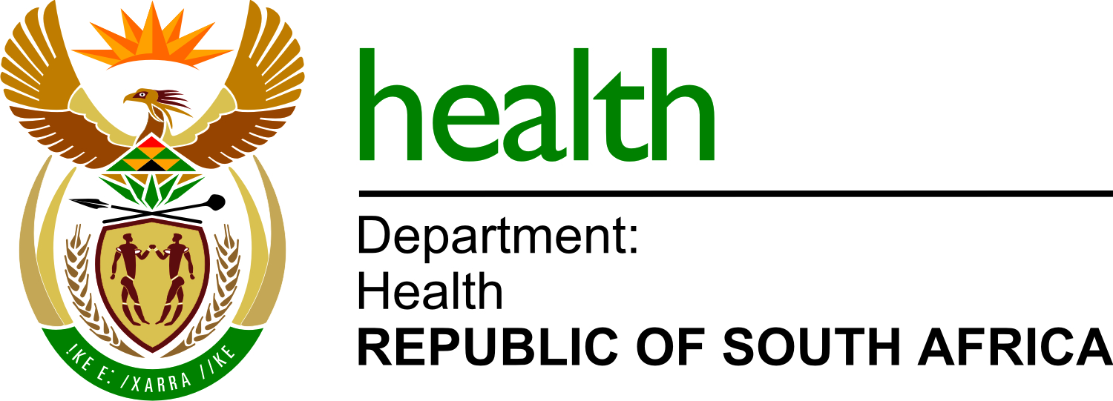

NDOH 28/2021-2022
Appointment of a service provider to supply, deliver and distribute basic life support (BLS) Essential Equipment and Training manuals for the National Department of Health.

List of bidders
1. | Survival Technology
2. | Medical Technology
3. | SSEM Mthembu Medical
4. | Anatomical
5. | ODIRE Consulting Services

